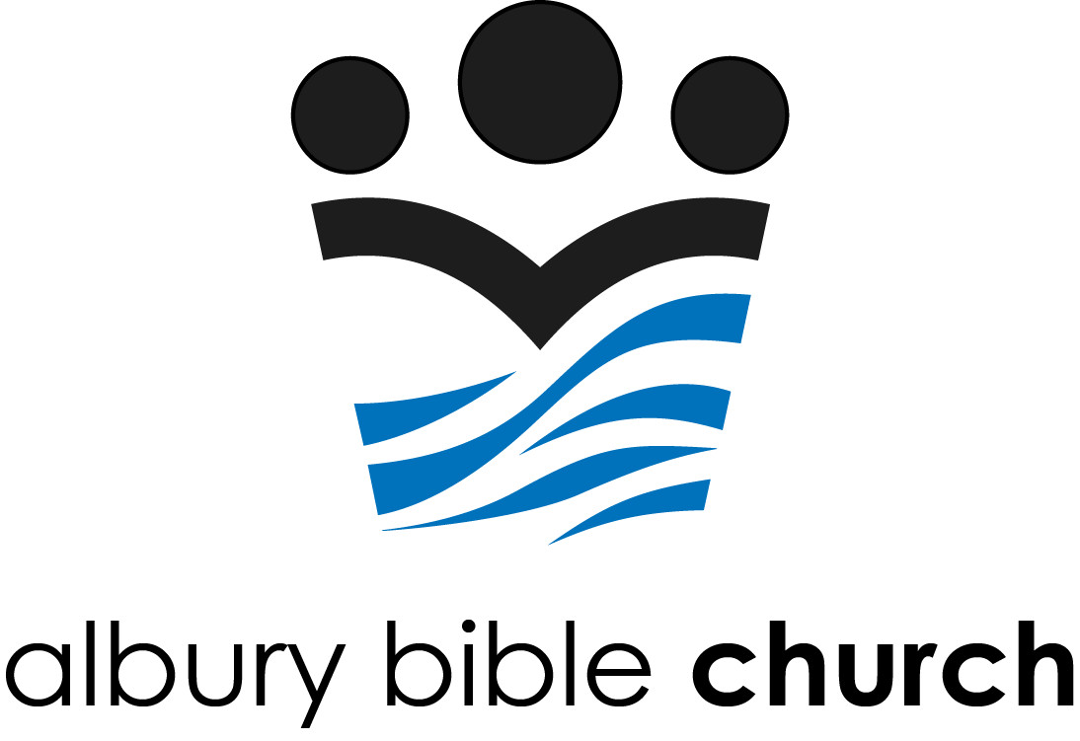

Albury Bible Church
Safe Ministry Policy

Aim
Albury Bible Church takes seriously the Bible’s mandate to be active in the welcoming, spiritual nurture, protection, safety and care of those in our ministries - both adults and children.
Albury Bible Church also aims to enable and protect those ministering to children.
To build and maintain a safe community for children and adults, we are committed to ensuring that:
- all leaders are appropriately screened, trained and appointed,
- all training and compliance is recorded,
- all programs are led and run in a safe and appropriate manner,
- there are clear incident reporting procedures in place,
- general completion of level 1 safe ministry training for ABC attendees is encouraged and
- the leadership at Albury Bible Church regularly reviews these policies and processes.

1. Screening, Training & Appointing of Leaders
All those involved in running ministries to children and adults on behalf of Albury Bible Church undergo a full screening and training process as outlined below.
- Leaders will have been regular participants at Albury Bible Church for at least six months (or have been given special approval by the church leadership). They will be interviewed and have their potential roles and responsibilities clearly outlined for them.
- Leaders will complete an approved Safe Ministry Training Course including nominating 2 referees. This course outlines appropriate behaviour as well as training in how to identify and report cases of abuse. (Albury Bible Church currently uses www.SafeMinistryCheck.com.au).
- If working with children & youth, leaders must provide Albury Bible Church with their unique Working with Children Check number and Date of Birth to be legally approved by the Commission for Children and Young People.
- SRE teachers will also receive specific training for classroom management and curriculum use via SRE Essentials (https://nswactbaptists.org.au/sre-training/)

Leaders will be asked to do revision training every three years.
Under no circumstances will a person with a criminal record of child abuse, molestation or similar offences be allowed to be involved in children's or youth ministry.

2. Appropriate Behaviours and Guidelines for Safe Ministries
To provide for, build and maintain a safe community for our children and adults where they may grow as followers of Jesus, we must ensure that our programs and events are safe and appropriate for those attending. For this to happen, all those ministering to children and adults at Albury Bible Church are to behave and act according to the values of the community, society and above all as followers of Jesus.
Our programs and events must be safe and appropriate to children and youth attending. Careful consideration will be made of things such as activities chosen, venue, safe supervision ratios, appropriate child toilet practices, transportation, occupational health and safety, parent or guardian permission and confidentiality of record-keeping.
Guidelines for these safe practice procedures are highlighted and discussed in the Safe Ministry Training Course.
To help maintain appropriate standards, all leaders and helpers will be given access to ongoing training and adequate supervision in their roles and responsibilities.
SRE teachers will also be subject to annual review (which could include teacher self-reflection, student feedback, classroom observation, supervisor feedback, or mentor support).
Albury Bible Church will participate in the annual SRE assurance process for the NSW Department of Education for the purpose of training and improvement.

3. Incident Reporting Procedure
If any leaders suspect a child or adult has experienced abuse they will not take action on their own or approach the suspected abuser. (There may be a perfectly good explanation for the injury or behaviour observed.) Leaders will raise the matter with one of the Albury Bible Church Safe Ministry Supervisors.
The Safe Ministry Supervisor will respond to all reports appropriately. Any allegations of criminal activity (adult-to-child, or adult-to-adult) will be reported to police. Any allegations of child abuse will be reported to the NSW Government according to the Online Mandatory Reporter Guide. The insurer of Albury Bible Church will also be advised of any allegations of abuse. Leaders may be required to provide a statement to the Police and/or to Family and Community Services if it is confirmed that a child is at risk.
An employee or volunteer shall be automatically suspended from their duties and roles if they are under investigation either internally or by police with subsequent termination if found guilty.
In various circumstances Albury Bible Church will appoint an Independent Ministry Investigator (IMI) to explore allegations of inappropriate behaviour. The steps involved in responding to allegations of abuse are outlined in the Albury Bible Church Safe Ministry Incident Response Process.

4. Regular Review Periods
It is the responsibility of the Senior Minister and Administration Committee to ensure that this policy and the Incident Response Process is implemented, maintained, and reviewed every two years or as required. (This includes appointment of church Safe Ministry Supervisors.) This policy is in accordance with the Children and Young Persons (Care and Protection) Act 1998 No 157.

Contact Details
Senior Pastor
Chris Little, minister@alburybiblechurch.com.au
Safe Ministry Supervisors
Chris Little, 02 6021 1910, minister@alburybiblechurch.com.au
Helen Hill, 0419 228 466 Helen_shirley@hotmail.com
Albury Bible Church
Office/postal address: 374 Amatex St, East Albury NSW 2640
Office: 02 6021 1910
We welcome any questions or comments about this policy and the ways in which we carry it out.

This policy is based on the Draft Policy provided at safeministrycheck.com.au formerly SafeMinistryTraining.com.au
First Adopted by Albury Bible Church administration committee on: 10 August 2014
Last reviewed by Albury Bible Church administration committee on: 6 September 2020
Reviewed June 2022
Next review date: June 2024

Deuteronomy 6:4-7; Matthew 18:1-6; Mark 10:13-16

